Project Design Phase-II
Technology Stack (Architecture & Stack)

Date | 22 January 2026
Team ID | LTVIP2026TMIDS87961
Project Name | Educational Organisation Using ServiceNow
Maximum Marks | 4 Marks

Technical Architecture:
The Deliverable shall include the architectural diagram as below and the information as per the table1 & table 2
Example: Order processing during pandemics for offline mode
Reference: https://developer.ibm.com/patterns/ai-powered-backend-system-for-order-processing-during-pandemics/
Guidelines:
Include all the processes (As an application logic / Technology Block)
Provide infrastructural demarcation (Local / Cloud)
Indicate external interfaces (third party API’s etc.)
Indicate Data Storage components / services
Indicate interface to machine learning models (if applicable)
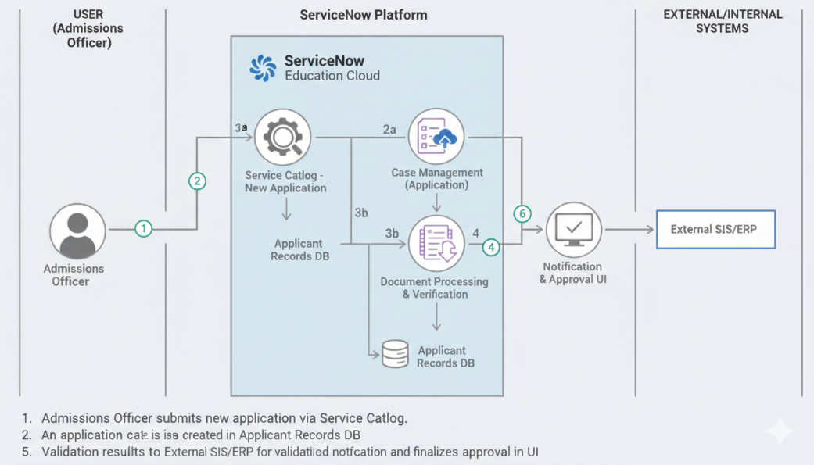

Table-1 : Components & Technologies:
S.No | Component | Description | Technology
- 1 | User Interface | Interface for students, teachers, and admins to interact with the system (portal & dashboards) | ServiceNow Portal, HTML, CSS, JavaScript
- 2 | Application Logic-1 | Core workflows for admissions, approvals, and user onboarding | ServiceNow Flow Designer / Business Rules
- 3 | Application Logic-2 | Academic processes like attendance, grading, and progress tracking | ServiceNow Scripts (Glide API / Script Includes)
- 4 | Application Logic-3 | Notifications and communication workflows | ServiceNow Notifications / IntegrationHub
- 5 | Database | Stores student, teacher, academic, and administrative data | ServiceNow Tables (Relational Database)
- 6 | Cloud Database | Managed cloud data storage within platform | ServiceNow Cloud Platform
- 7 | File Storage | Storage for documents like certificates, admission forms, reports | ServiceNow Attachment Storage
- 8 | External API-1 | Email/SMS service for alerts and notifications | SMTP / SMS Gateway Integration
- 9 | External API-2 | Identity or authentication integration (if required) | SSO / OAuth / Institutional Identity API
- 10 | Machine Learning Model | Predictive insights such as student performance analysis (optional) | ServiceNow Predictive Intelligence
- 11 | Infrastructure (Server / Cloud) | Hosting and deployment environment | ServiceNow Cloud (SaaS Platform)

Table-2: Application Characteristics:
S.No | Characteristics | Description | Technology
- 1 | Open-Source Frameworks | UI enhancements and integrations may use open web technologies for portals and custom widgets | HTML, CSS, JavaScript, Bootstrap
- 2 | Security Implementations | Secure authentication, role-based access, data encryption, and compliance with security best practices | ServiceNow IAM, Role-Based Access Control (RBAC), SSL/TLS Encryption, OAuth
- 3 | Scalable Architecture | Cloud-based multi-tenant architecture that supports growing users and data without performance degradation | ServiceNow SaaS Architecture (Multi-instance, 3-tier architecture)
- 4 | Availability | High availability ensured through cloud infrastructure with redundancy and failover mechanisms | ServiceNow Cloud Infrastructure, Load Balancing, Data Replication
- 5 | Performance | Optimized workflows and database queries with caching and efficient processing for fast response times | ServiceNow Performance Analytics, Caching, Optimized Business Rules

References:
https://c4model.com/
https://developer.ibm.com/patterns/online-order-processing-system-during-pandemic/
https://www.ibm.com/cloud/architecture
https://aws.amazon.com/architecture
https://medium.com/the-internal-startup/how-to-draw-useful-technical-architecture-diagrams-2d20c9fda90d

